Design of Tashjik: TransportLayerCommunicator

Name | Date | Comment
Ratul Mukhopadhyay | 26 Jan 2010 | Quick description of the API

Description of the API:
The TransportLayerCommunicator class is part of Tier 0 of Tashjik. It is the lowest tier, and is responsible for communication with the transport layer. There are three things that need to be done while using this API. A client that wishes to use this layer needs to register with it. During registration, it specifies call back functions that need to be called when message are received from the network. The client also needs to provide a Guid to uniquely identify itself from other clients. This is described in section 2.

1. Sending messages
Three important methods to send data are given below. These are asynchronous operations, and return immediately after they are called. User needs to provide a callback function ‘AsyncCallback callBack’, that will be called once the operation is done. It can also supply state information that it may require later after the operation: ‘Object appState’,

These functions need to be supplied the IP address of the remote machine where the message needs to go. The message itself is defined by ‘byte[] buffer, int offset, int size’. Buffer points to a byte array. The message of length ‘size’ is extracted from it starting at the position ‘offset’

clientGuid denotes the Guid of the caller. In Tashjik’s case, it is usually an overlay implementation built on top of this tier. But it could be any other client program.

The third method BeginTransportLayerSendTwoWayRelay(…) has an extra parameter: ‘Guid relayTicket’, which will be explained below.

- public void BeginTransportLayerSendOneWay (IPAddress IP, byte[] buffer, int offset, int size, Guid clientGuid, AsyncCallback callBack, Object appState)

This function is used to send data to a particular remote machine. No return value is expected. Only a one-way message is sent.

- public void BeginTransportLayerSendTwoWay(IPAddress IP, byte[] buffer, int offset, int size, Guid clientGuid, AsyncCallback callBack, Object appState)

This function is used to send data to a particular remote machine, and then expect another message in return. The returned message should come from the same remote host. When TransportLayerCommunicator receives the return message, it calls notifyTwoWayReplyReceived (…) defined in the interface ISink which is implemented by the client.

- public void BeginTransportLayerSendTwoWayRelay(IPAddress IP, byte[] buffer, int offset, int size, Guid clientGuid, AsyncCallback callBack, Object appState, Guid relayTicket)

This function is used to send data to a particular remote machine, and then expect another message in return. The returned message need not be returned from the same remote host. In fact this message can be relayed to different hosts, until finally a host responds back with a return message. When TransportLayerCommunicator receives the return message, it calls notifyTwoWayReplyReceived (…) defined in ISink which is implemented by the client.

This function was implemented because many peer-to-peer systems use some kind of relaying mechanism to relay a request. When a node that is supposed to respond is reached, it sends data directly to the originator of the request.

By implementing this functionality at this layer, we remove the burden of common relay implementation from the upper layers.

The first time a message is sent out, relayTicket is a NULL guid. Supposing a remote host receives this message, but does not have the data to respond back. It needs to relay the message to another remote host. It then calls this function with a corresponding relayTicket. This ticket would have been supplied to it when it received the data via the callback function notifyTwoWayRelayMsg(… Guid relayTicket …) defined in ISink. The relayTicket identifies the particular relay that is used to traverse the message over the network.

After these operations have returned via the callback functions defined in ISink, user needs to call the following methods:

public void EndTransportLayerSend(IPAddress IP)

2. Registration and receiving of messages
Any client that needs to use this layer has to register with it. The client could be any of the higher tiers, or it could be a separate client program altogether. This means that multiple clients can use the same layer to send and receive messages to different remote hosts.

Registration is done by calling the function:
- public void register(Guid guid, ISink sink);

Guid is a unique Guid that will identify the client from other clients. Using this Guid, TransportLayerCommunicator sends all messages that are to be received by the client to it. Once a message is received from the lower transport layer, the Guid is used to decide the client to whom it needs to be delivered. On identification of the client, it sends the received message to it by the use of ISink interface.

ISink is an interface that the client needs to implement. Whenever data needs to be sent to the client, TransportLayerCommunicator will call one of these functions to send that data.

- public interface ISink
{
void notifyOneWayMsg(IPAddress fromIP, byte[] buffer, int offset, int size);
Data notifyTwoWayMsg(IPAddress fromIP, byte[] buffer, int offset, int size);
Data notifyTwoWayRelayMsg(IPAddress fromIP, IPAddress originalFromIP, byte[] buffer, int offset, int size, Guid relayTicket);
void notifyTwoWayReplyReceived(IPAddress fromIP, byte[] buffer, int offset, int size, AsyncCallback originalRequestCallBack, Object originalAppState);
}

notifyOneWayMsg(…): A message has been received from a remote host. The remote host would have called BeginTransportLayerSendOneWay(…) to send a one way message.
notifyTwoWayMsg(…): A message has been received from a remote host. This remote host would have called BeginTransportLayerSendTwoWay(…) to send a two way message. It expects an answer from this machine now.

notifyTwoWayRelayMsg(…): A message has been received from a remote host. This remote host would have called BeginTransportLayerSendTwoWay(…) to send a two way message. It expects an answer from either this machine or some other machine to whom its message has been relayed to.

notifyTwoWayReplyReceived(…): A message has been received from a remote host. This remote host would have earlier received a direct or a relayed message, and it responded to the originator of the message, that is myself.

Send OneWay
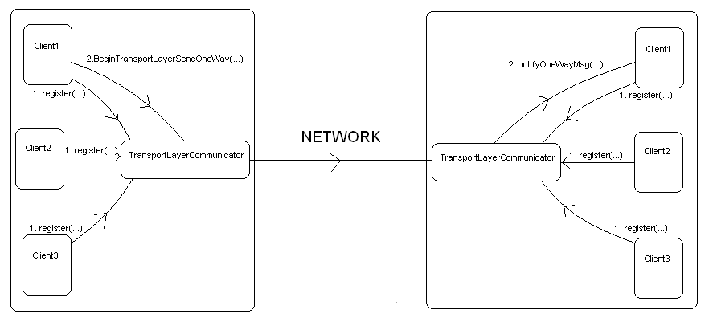

Send TwoWay

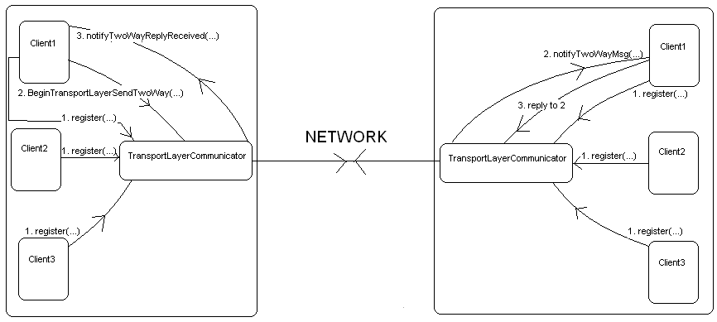

SendTwoWayRelay
Relay mechanism diagram hasn’t been added. In this diagram, there will be three nodes. First node will send a TwoWay Relay message to the second node. The second node will relay it to the third node. And node three will finally reply back directly to node one.

